Get a .pcap file
Use trusted public sources:
- Wireshark Sample Captures
- Malware-Traffic-Analysis.net
Download any .pcap file.

Launch Wireshark

Step 1:- Open a .pcap file in Wireshark
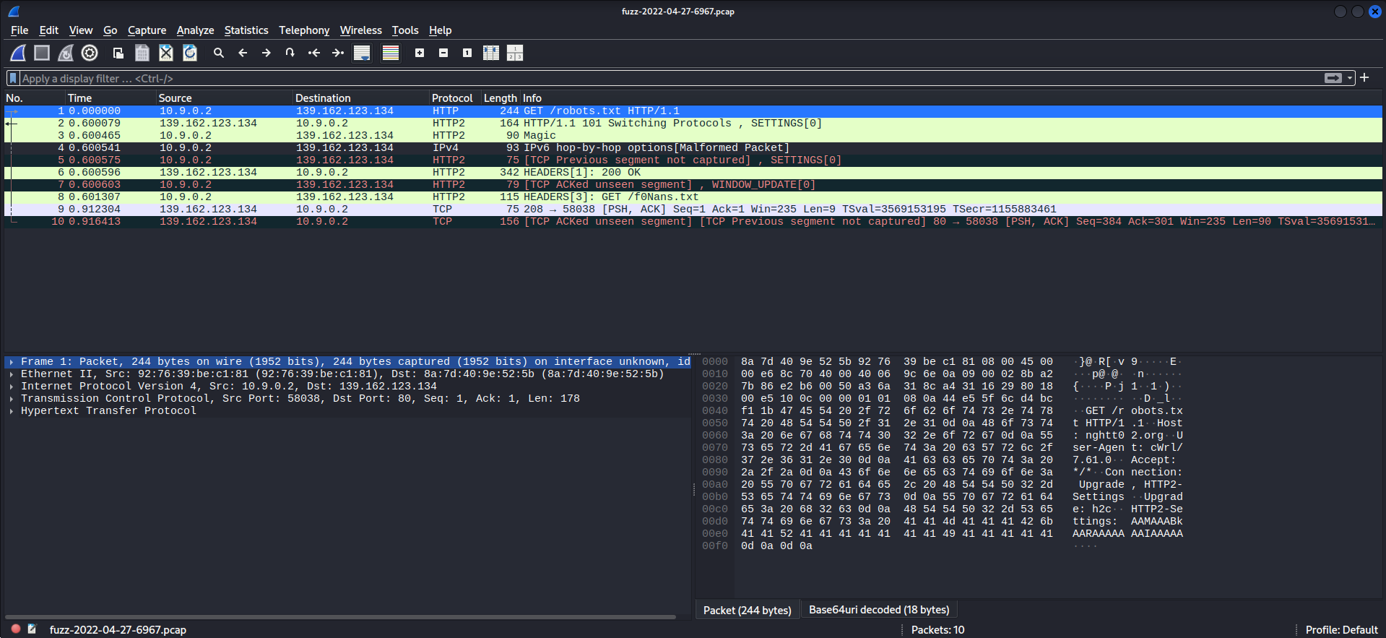

Step 2:- Identify Protocol (Statistics -> Protocol Hierarchy)

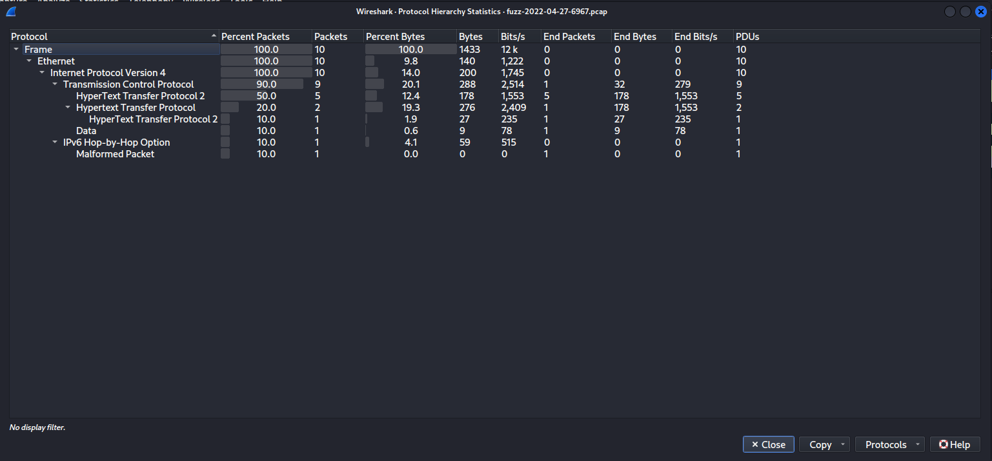

Step 3:- Find IP Addresses (Statistics -> Endpoints)
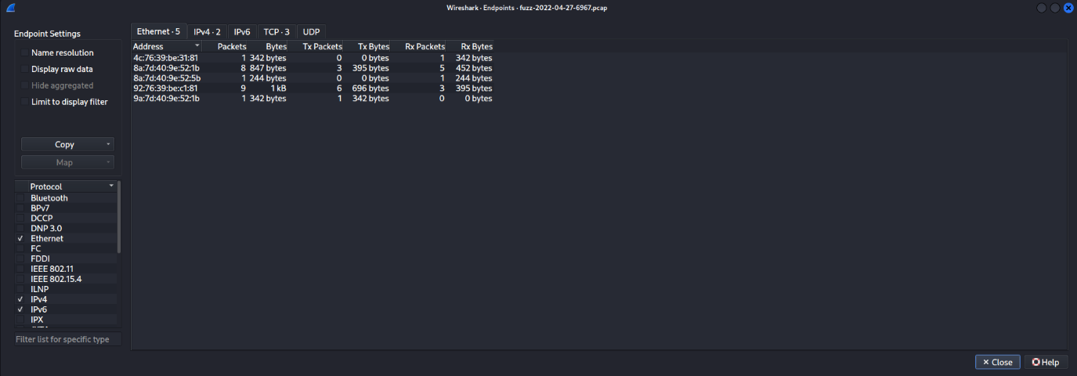

Step 4:- Filter and find different packets for different protocols (ip, dns, tcp)
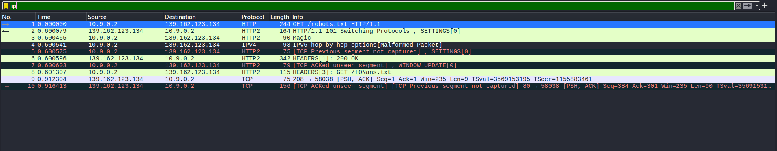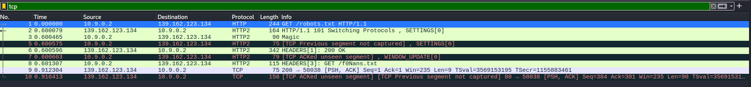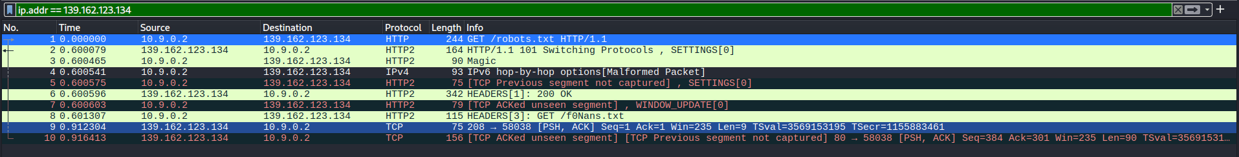

Step 5:- Click on any packet for its information
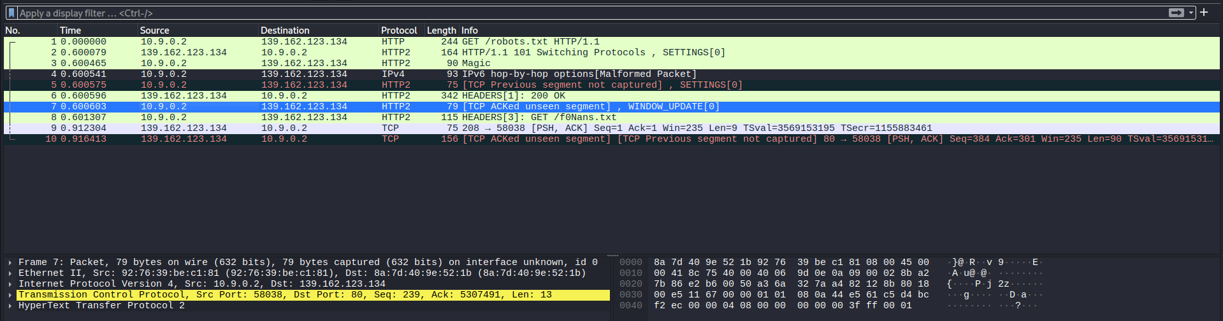

Step 6:- Follow a stream (Follow -> TCP Stream)
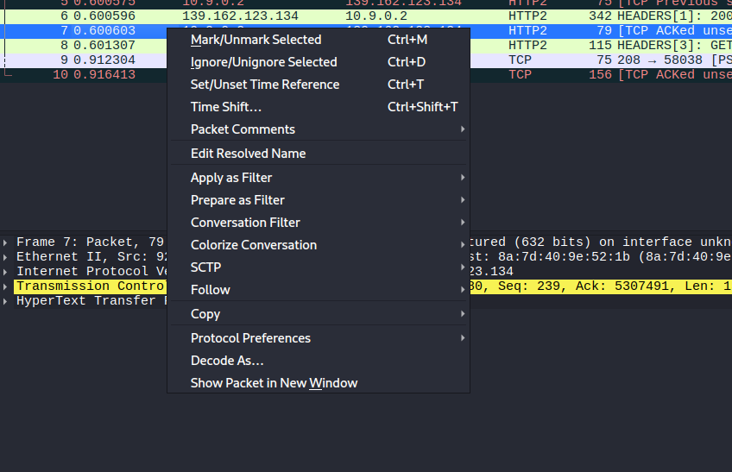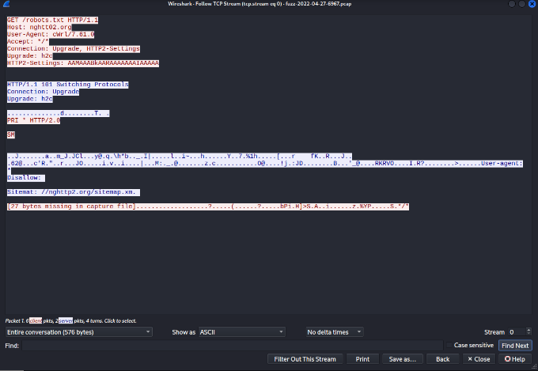

Step 7:- IO Graph (Statistics -> IO Graph)
